Robot Design Module

Team TechKnights’ Alliance - AIITRA ‘21

# Scoring criteria :

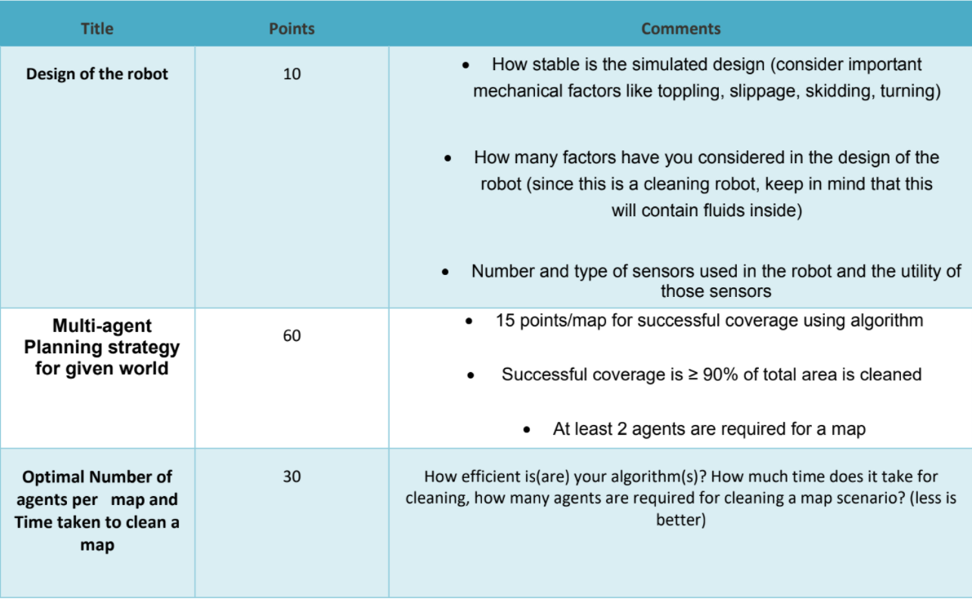

# Objectives (Module relevant) :

1. Robot Designing

* Detail the dimensions of the given maps.
* Decide Motion Controls
* Design the robot
  + Dimensions
  + Mass
  + Strength
  + Material
* Decide Dynamics Constraints based on the design
* Encompass Sensors, onboard computer etc in the design parameter
* Model the bot

# Basic Procedure:

Bot Design

* Shape
  + Round vs Square
  + Pros (Round)
  + The typical shape of a robotic vacuum cleaner is a disk. The reasons they are disk-shaped is because of mobility. They can maneuver through tight spaces and still clean effectively. When they bump into a wall or piece of furniture, since it is a circle, it can easily turn around and adjust its position and continue cleaning.
  + Cons
  + The major problem with the vacuum being a circle is that it cannot clean the corners of rooms very well.
  + Pros (Square)
  + If you change the shape to a square, then the vacuum can get into the corners and clean better, but there are no square robot vacuums.
  + Cons
  + As the vacuum is going along and cleaning it will bump into obstacles and then reposition itself. As the vacuum is re-positioning itself, the edges can come into contact with obstacles and will waste more time re-positioning itself instead of cleaning.

-----------------------------------------------------------------------------------------------------------------------------------------

Refer : <https://web.stevens.edu/ses/me/fileadmin/me/senior_design/2007/group01/DesignFinal.pdf>

( Added to References )

<https://www.sci.brooklyn.cuny.edu/~sklar/teaching/f06/cis1.0/papers/roomba-howstuffworks.pdf>

Effective Cleaning Radius

Effective cleaning area

Dynamic limits (Turning radius, Turning Speed, Straight speed, Acceleration)

Cost for optimization.

[acc calc](https://www.researchgate.net/post/How-can-I-determine-the-maximum-speed-of-an-omnidirectional-robot-with-a-ring-of-sequentially-firing-nnumber-of-ultrasonic-sonar-sensors)